**Experiment 1**

**Programs on Basic Programming constructs like branching and looping**

//Programs on Basic Programming constructs like branching and looping

//Write a program to print even number.

public class exp1_1{

    public static void main(String[] args) {

        System.out.println(&quot;\nProgram is showing even no.&quot;);

        for (int i = 2; i &lt; 20; i++) {

            if(i %2 ==0){

                System.out.print(&quot;\n &quot;+i);

            }

        }

    }

}

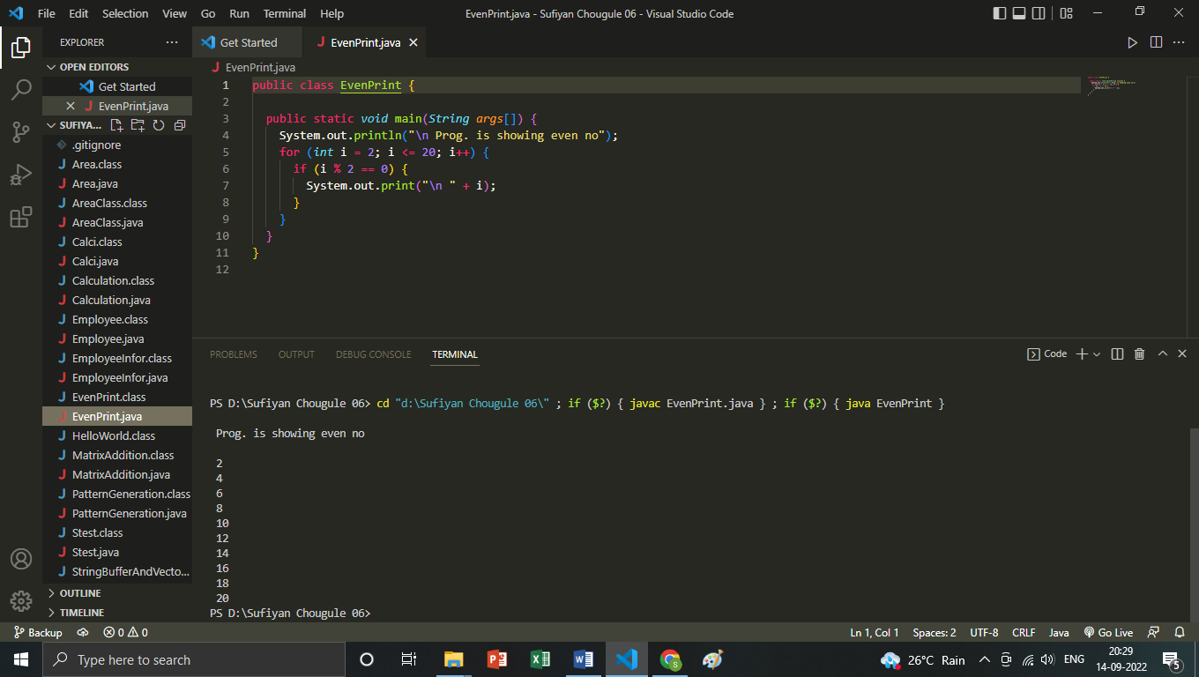

//Write a program based on Pattern Generation

import java.util.*;

public class PatternGeneration {

    public static void main(String[] args) {

        Scanner sc = new Scanner(System.in);

        System.out.println(&quot;Enter the no. of rows&quot;);

        int n = sc.nextInt();

        for (int i = 1; i &lt;=n; i++) {

            for (int j = 0; j &lt; i; j++) {

                System.out.print(&quot;*&quot;);

            }

            System.out.println();

        }

        }

    }

